NSW Traffic Penalty Analysis Software Executive Summary

Zoe Waters – s5131193 Elliott Horne - s5222361

2810ICT Software Technologies

October 9, 2022

Abstract
All functions work as designed and successfully analyzes and filters the data. The date range function successful produces all rows within the dates inputted. The offense code function successfully displays the top twenty cases between two dates in a graph. The radar function successful displays any rows that contain the word camera or radar and is in the date range specified. The mobile phone function successfully displays the top 3 case codes and successfully displays the occurrences trend over time with the line graph. The custom query successful displays the data relating to the keyword and it keeps the data between the two date ranges given

Introduction
This report is to go over the functions of the NSW Traffic Penalty Analysis Software and reports the data that it produces is accurate. There were five different functions that the program has that displays filtered information from the massive NSW Traffic Penalty database. The date range shown in this test is from 2013-2014 and the key word for the custom query is ‘stop’.
All functions produced the correct data based on what the function is designed to do.
The date range function finds all the rows within the dates specified and prints them, as this function can produce a lot of results, a next button is provided. It displays ten results with a button to scroll through the rest of the results. This function looks at the 'OFFENCE_MONTH' column as it contains the full date, so the user can search down to the day with this function.
The offense code function takes the user inputted date range and finds the top twenty results for the total case code entries. These results are represented with a bar graph.
The Radar/Camera function takes all the rows between the user specified dates and prints out any results that contain “Camera” or “Radar” in the “OFFENCE_DESC” column. It displays 10 results with a button to scroll through the rest of the results.
The Mobile Phone function takes the chosen case code and gets the total occurrences per year and displays the data in a line graph to show the distribution over time. This data takes the top three codes and can only be changed if more data is added to the database, thus it also cannot show only twelve months of results.
The Custom Query function takes a key word as well as date range and finds all rows where the keyword matches a word in the “OFFENCE_DESC” column and is in between the defined dates. It displays ten results with a button to scroll through the rest of the results.

Analysis 1 <Date Range Function >
This function correctly shows all dates between the dates and only shows those data’s, these results are only ordered in how they appear in the database and have no other ordering, Only the first 3 pages page of results will be posted as a 12 month search for 2013-2014 results in over 36,000 rows.
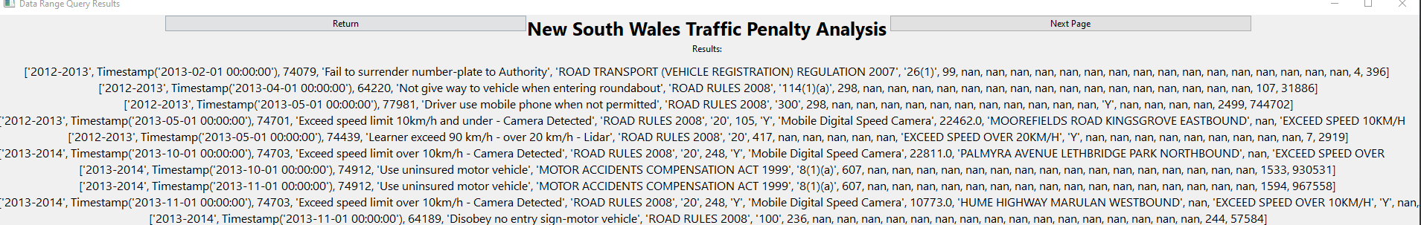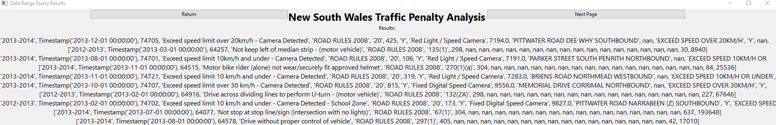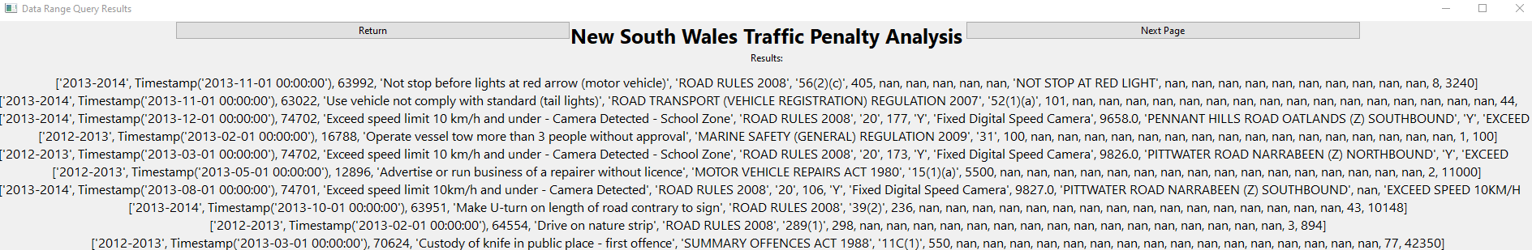Analysis 2 <Offence Code Function >
This function correctly plots all the occurrences and correctly gets the top 20 as seen by the graph showing a downward trend.
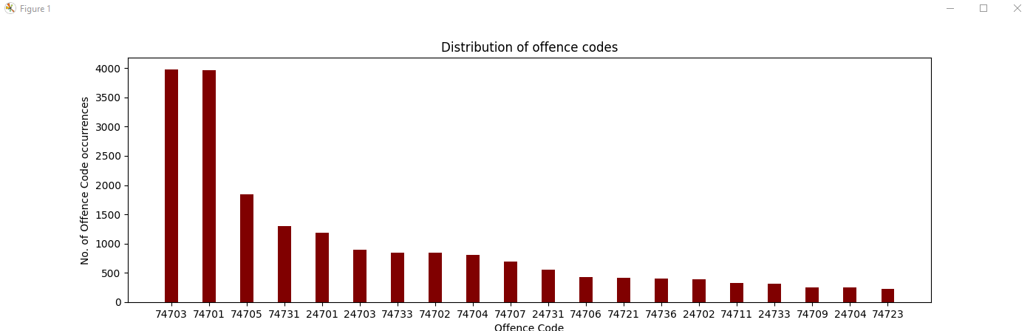

Analysis 3 <Radar/Camera function>
This function is correctly finding all and only results that contains either the word “camera” or “radar” in the description column and listing them all. As with the date range function, there are too many results to post for the entire 12 months.
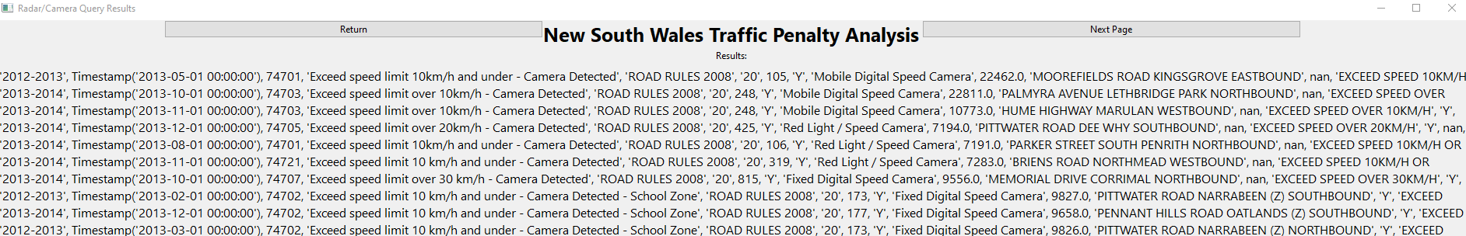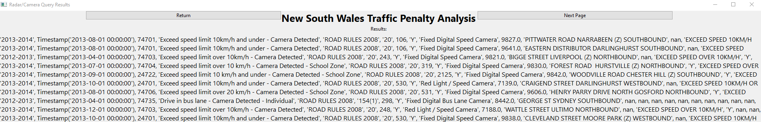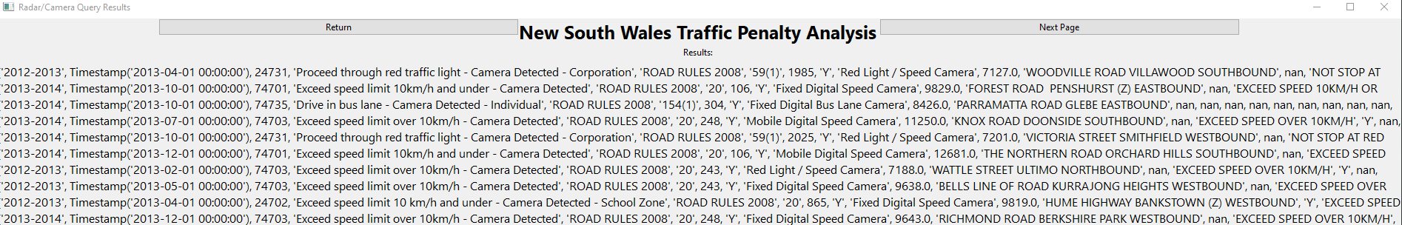

Analysis 4 <Mobile Phones function>
This function is correctly getting the occurrences for the case code for each year and is plotting the data correctly into the graph

Analysis 5 <Custom Query function>
This function is correctly finding all and only results that contains the word ”stop” in the description column and listing them all.
